Translate Secondment Scheme: Devices for Dignity (D4D) HTC Opportunity

The Leeds City Region is a driving force for the UK healthcare sector, with world-leading clinical expertise and research and development capacity across its universities, hospitals, healthcare and medical device manufacturing sectors.

Translate: Medical Technologies in the Leeds City Region is a partnership of universities in the Leeds City Region with world-class expertise in the development of new medical technologies. It aims to develop nationally leading capability in Medical Technology Innovation in the Leeds City Region, establishing a sustainable community of academic, industry and clinical partners that are connected and committed to working in partnership to deliver a strong local economy and patient benefits. The programme is financed by the HEFCE Catalyst Fund.

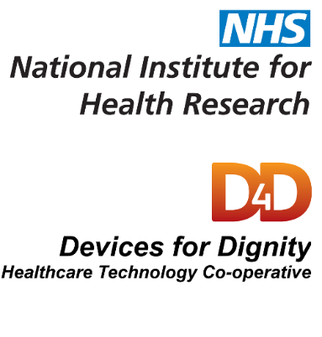
Devices for Dignity Health Technology Cooperative (D4D) is a national initiative funded by the National Institute for Health Research (NIHR), to act as a catalyst within the NHS for the development of new medical devices, healthcare technologies and technology-dependent interventions. D4D operates nationally, bringing together the right team of expert clinicians, academics, members of the public, carers, charities and industry to deliver solutions to address specific needs. D4D recognises the important impact of overlapping complications and illnesses on quality of life and the ability to live and function independently – it’s patient focus is “Living my life well for longer”.

Purpose of the scheme | To develop the innovation skills and translational capability of medical technology researchers in the Leeds City Region.
Secondment opportunity | We are seeking a post-doctoral researcher or early career academic (based at one of the Translate partner universities: University of Bradford, University of Huddersfield, Leeds Beckett University, University of Leeds, University of York) who is interested in learning about the process around the development of new medical devices/healthcare technologies and by providing expert advice and support to take new healthcare products to market.  The successful candidate will support us to evaluate ideas for commercial potential and research/present relevant information about the opportunity to attract funding, partners and/or investors. There will also be the opportunity to work alongside our Innovation Managers to further develop our in-house Innovation Manager system.  We also facilitate a number of workshops, provide project management support and grant writing support. There may be opportunities over the secondment period to get involved with these activities also.  Support will be provided to the secondee by all members of the D4D team, particularly the Innovation/Project Managers.  This opportunity is available at two days (or 15 hours) per week for 3 months. The ability to be flexible with days would be advantageous.  The successful candidate will be expected to work from the D4D office at the Royal Hallamshire Hospital, Sheffield, and may occasionally be asked to attend meetings off-site with D4D staff members.  Basic IT and research skills, as well as the ability to interact with different stakeholders (e.g. NHS, services users, industry, University) are expected as a minimum.
Funding | Funding (up to a max of £2.5K*) is available to cover the following costs:  - Travel to/from the host organisation  - Accommodation and subsistence costs for the duration of the secondment  Other associated costs will be considered on a case-by-case basis.  Please note that this scheme does not provide funding for conference attendance, electronic equipment (such as laptops), or salary costs.  (*Applicants are encouraged to seek co-funding from, for example, their host university - where appropriate.)
How to apply | Completed applications should be emailed or posted to:  Dr Danielle Miles - X101 Medical and Biological Engineering - University of Leeds - Leeds LS2 9JT – d.e.miles@leeds.ac.uk  Completed applications must be received by 5pm on Friday 29 September 2017.
Assessment process | Applications will be assessed by representatives from D4D HTC and the Translate programme.  We will consider the following:  - Acquisition of new knowledge and skills  - Impact on career development  - Benefits to your research group or immediate community  - Benefits for the host organisation  - Development of new collaborations

Conditions of award | The successful candidate will be required to:  - Attend two Translate workshops  - Provide a final report (template to be provided)  - Provide a minimum of three blog posts about their secondment for the Translate website  S/he may also be invited to present at Translate events.
Further information | For further information, please contact: Dr Danielle Miles, Translate Technology Innovation Manager  Email:d.e.miles@leeds.ac.uk Tel: 0113 34 30921

Translate Secondment Scheme – D4D Secondment – Application Form

APPLICANT DETAILS:
Title
Forename
Surname
Job title / role
Research group
University
Email address
Line manager / supervisor

If your secondment is approved, it will be necessary to obtain a collaboration agreement before funds can be released. It will also be a condition of funding that relevant Health and Safety procedures are put in place to support your secondment.

DURATION / START:
Please indicate your preferred start date:

BENEFITS OF SECONDMENT:
Please provide an outline of the anticipated benefits of the secondment in terms of personal development, benefits to your immediate research community, and benefits to the host organisation. (Max 500 words.)

FUNDING REQUESTED:
Travel
Accommodation / Subsistence
Other (please specify)
TOTAL

SIGNATURES:
Applicant: | Date:
Line manager / supervisor: | Date:

